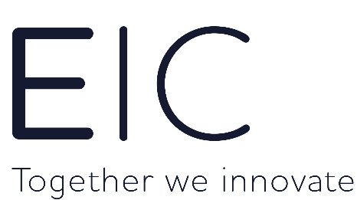
RECRUITMENT AGENCY CVs WILL NOT BE CONSIDERED

ENERGY INNOVATION CENTRE – Graduate Innovation Engineer
We have a great opportunity for an ambitious Graduate Engineer to join our team!
You will become part of a dynamic and growing company in the global energy sector, whilst being supported to grow and develop, realising your own potential.
The Energy Innovation Centre (“EIC”) was launched in 2008 to accelerate the discovery, development and deployment of innovation for the Energy industry to achieve net zero by 2050. At the EIC, we support the innovation ambitions of our industry partners from the gas, electricity and other utility sectors by helping them to discover new technologies that meet their challenges. We do this by constantly searching for new ideas from around the world that have the potential to be game-changing for energy consumers, the supply chain and the industry itself. Once we have identified these ideas and technologies, we help the people behind them to get access to the large energy companies and together help drive these innovations to the next stage of their development.
The specific role details are:
Role Summary:
- Operate as an innovation scout, who will seek out and identify new technologies for our energy network partners
- Identify innovative companies and individuals that have the potential to deliver technologies that can address a diverse range of energy network challenges
- Draft, critique and launch calls for innovation and calls to industry as well as deliver market research on behalf of the EIC partners (Electricity Distribution Network Operators (DNOs), Gas Distribution Network Operators (GDNs), Transmission Operators (TOs) and other utilities)
- Assess and validate proposed solutions prior to presenting to EIC partners
- Work with senior engineers to carry out the due diligence required to support investment in technologies by energy industry
- Facilitate small group workshops with EIC partners
- Support the development of project plans that will ensure the smooth delivery of projects
- Coordinate and support trials and project delivery
- Proactively identify and manage issues and blockers to ensure the successful delivery of innovative solutions to the energy industry
- Contribute to the continuous improvement of processes to generate efficiencies within the business

Essential Requirements for the role :
The ideal candidate will have a strong interest in the energy sector and good interpersonal skills. for the candidate must also be a self-motivated team player who can be part of a unique culture.
- A Degree in a subject related to the energy industry.
- Sound knowledge of engineering principles with analytical skills are essential to identify credible technologies and identify value adding applications in the energy networks.
- An understanding of regulatory environment.
- Excellent communication skills (specifically excellent report writing and presentation skills)
- Keen eye for detail.
- Good team player with a flexible approach to work
- Full UK driving license

Desirables:
- Project management / authoring experience
- Small to medium group facilitation experience
- Understanding of legal and commercial factors associated with product development
- Knowledge of RIIO regulatory period and of both NIA and SIF funding streams
- Experience of DNOs, GDNs, TOs or other regulated utilities planning, investment management, policy & standards

Pay and benefits:

- Salary: Competitive for graduate position
- 25 days annual leave
- 10% employer contribution into a non-contributory personal pension plan
- Private medical insurance
- Professional subscription fees
- Flexible working hours/Hybrid working

To be considered for this role, please send a full CV and covering letter telling us why you’re the right person to help accelerate our firm’s momentum.

