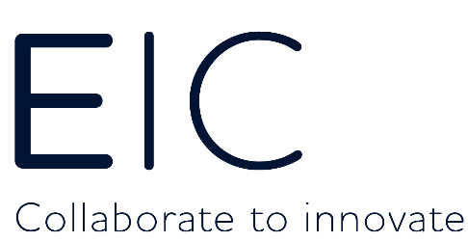

EIC – Innovation Delivery Co-ordinator
The Energy Innovation Centre (EIC) is a dynamic and fast evolving company in the global utility innovation sector. The EIC vision reaches far beyond the improvement of utility systems. Our passion for driving social progress, improving the quality of people’s lives and securing a safe, affordable and sustainable future is at the heart of everything we do.
The successful candidate will work closely with the Head of Discovery & Development and Innovation Engineers.
The duties will include:
- Liaise with partner District Managers to support the identification of innovation needs, and the development and delivery of innovative solutions into business as usual.
- Provide proactive administrative and co-ordination support to account managers to arrange & deliver partner account management activities in a timely manner.
- Provide proactive administrative and co-ordination support for transmission networks collaboration activities, including preparation of agenda and minutes.
- Provide support with the arrangement of Innovation Labs including the use of interactive white boards.
- Support EIC Innovation Engineers as required.
- Schedule meetings to support the delivery of projects as appropriate.
- Preparation of information in support of meetings (presentations, preparing info for attendees) including setting up of relevant video conferencing equipment.
- Maintain scheduling for recurrent meetings.
- Minute taking, circulate for approval and formally issue.
- Organising and maintaining diaries and making appointments.
- Screening phone calls, enquiries and requests and handling them where appropriate.
- Producing documents, briefing papers and agendas.
- Arranging occasional offsite visits.
- Be responsible for keeping internal systems up to date.
- Undertake other support duties as required.
Essential Skills, Experience and Attributes:
- Interest in the electricity and gas utility networks
- A willingness to embrace technical terminology
- Excellent word processing and IT skills, including knowledge of Word, Excel and PowerPoint
- Exceptional written and oral communication skills
- Excellent knowledge of appropriate research tools, including searching for and downloading data
- Ability to work under pressure and to tight deadlines
- Excellent organisational and time management skills
- Excellent interpersonal skills
- Accuracy and attention to detail
Flexibility and ability to juggle a range of different tasks.
You will be a self-starter with excellent self-motivation and a commercial flair for innovation. Attention to detail will be essential as well as being a team player with a flexible approach to working hours.

Pay and benefits:
- Salary dependant of experience
- 25 days annual leave
- 10% employer contribution into a non-contributory personal pension plan
- Private medical insurance
- Professional subscription fees
- Childcare vouchers
- Flexible working

Interested? Then send us a one-page letter (and attach your CV) telling us why the EIC and the role would be ideal for you and why you would be ideal for the EIC to sallyann.greedy@ukeic.com

