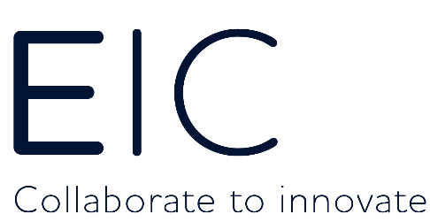

EIC - Business Intelligence & Digitalisation Analyst
Business Insight | Digital Experience | Collaborator | Future thinker | Net Zero

A unique and exciting opportunity to be a part of a dynamic innovation company in the global energy sector.
We are looking for an experienced and ambitious individual to join the Energy Innovation Centre (EIC) as Business Intelligence & Digitalisation Analyst.

The EIC scans the globe to find innovators with ground-breaking new ideas to fulfil the innovation ambitions of our major industry partners from the gas and electricity sectors. We then accelerate the development and deployment of those innovations. Innovations that improve efficiency, safety and reduce CO2. Our role is challenging, worthwhile and important.

If you are ready to fully commit to an organisation with a culture that cares about your wellbeing and personal development where you can give of your best so that it can continue to excel, then the EIC could be the company you have been looking for.

Role Summary

As Business Intelligence & Digitalisation Analyst, you will be responsible for all internal and external workstreams relating to data, digitalisation, business insight and IT to ensure that an evolving and “best in class” digital experience is provided to colleagues, Innovators and our Industry partners.
This includes:
- Pro-active internal and external performance reporting of EIC activities to drive action, inform business strategy and identify potential risks (including regular ad hoc and quarterly Board reporting)
- Providing regular or ad-hoc actionable business intelligence and insight through the use of data analytics, visualization/dashboards and modelling techniques
- Supporting efficiency improvements and the automation of business processes by researching and applying novel techniques such as Artificial Intelligence and data scraping
- Maintenance of the EIC Digital assets and systems through external IT suppliers.
- Contribution to the development and implementation of an EIC digitalisation strategy

Requirements:
- At least 2 years’ experience working with business systems, data, visualisation and analytics tools (Tableau experience desirable)
- Pro-active, self-motivated with a focus on delivering outputs
- Relevant post graduate Degree or Professional qualification
- Experienced in scoping and managing software developments
- Highly proficient in the use of MS Excel, particularly in the analysis of multiple datasets
- Experience of advanced data analytics and insight techniques
- Proven ability in using reporting and analysis to influence senior stakeholders and improve business performance
- An excellent team player and relationship builder, able to support a high performing team and work effectively with colleagues
- Excellent communication, verbal and written skills
- Strong interpersonal skills and an ability to communicate clearly and confidently with stakeholders at all levels of seniority and to a non-technical audience
- Keen eye for detail.

The ideal candidate must demonstrate a solid track record in a similar role. You will be focused and professional, someone who works effectively with a Senior Leadership Team and takes a proactive approach to driving new business initiatives, as well as taking responsibility for the day-to-day management of data and reporting.

Pay and benefits:

- Salary depending on skills and experience
- 25 days annual leave
- 10% employer contribution into a non-contributory personal pension plan
- Private medical insurance
- Professional subscription fees
- Flexible working hours/Hybrid working

Interested? Then send us a one-page letter (and attach your CV) telling us why the EIC and the role would be ideal for you and why you would be ideal for the EIC. Please send to Sallyann.Greedy@ukeic.com

